Alu-Containing Exons are Alternatively Spliced

Rotem Sorek, Gil Ast, and Dan Graur
Genome Research, pp. 1060-1067, 2002

Abstract

Numerous studies describe exonizations of Alu elements, that is, splicing–mediated insertions of parts of Alu sequences into mature mRNAs. Alu-containing exons were included in transcripts at lower frequencies than alternatively spliced exons that do not contain an Alu sequence. Presumably, evolutionary events that cause a constitutive insertion of Alu sequence into an mRNA are deleterious and selected against.

- Introduction

Alu elements are short interspersed elements (SINEs), typically 300 nucleotide long which account for 10% of the human genome. Despite their being genetically functionless, Alu elements have been suggested to have broad evolutionary impact. Under the assumption of 30000 genes in human genome, there should be ~400 genes that contain fragments of Alu elements in their protein-coding regions. The insertion of an Alu sequence into a mature mRNA may cause a genetic disease, but an Alu insertion may also contribute to protein variability and versatility.

- Result

We chose to work with internal exons because the prediction of terminal exons using EST alignments is problematic. An internal exon was classified as an alternative internal exon if there was at least one sequence that contained both flanking exons, but skipped the middle one.
There are several reasons for not identifying all internal exons. First, a large number of ESTs that represent intron contamination align to places in the genome that are normally introns. Second, for the set of constitutively spliced internal exons, we chose only exons supported by four sequence or more, namely from relatively highly expressed genes.
Most Alu-containing exons have a small retention ratio.
All Alu elements found within exons were extendgin into at least one of the flanking introns.
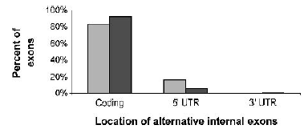

- Discussion

From our results, it is clear that constitutive Alu-containing internal exons are either absent or very rare in human transcriptome, whereas alternative Alu-containing internal exons appear frequency.
We have chosen to focus on alternative splicing events of the exon-skipping type for two reasons. First, this type is the most frequent type of alternative splicing. Second, many unspliced ESTs found in the ESTs database represent sequenced introns (intron contamination) and contain Alu sequences, and, therefore, preferred not to use unspliced expressed sequences as evidence for alternative splicing.

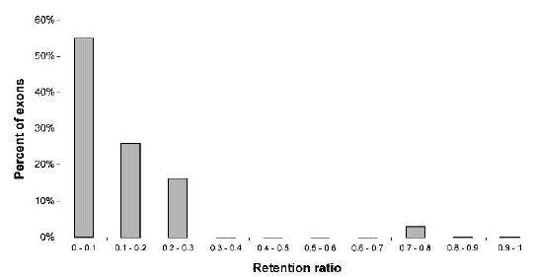

Created by: Chia-Chang Wang
Date: March 25, 2004

